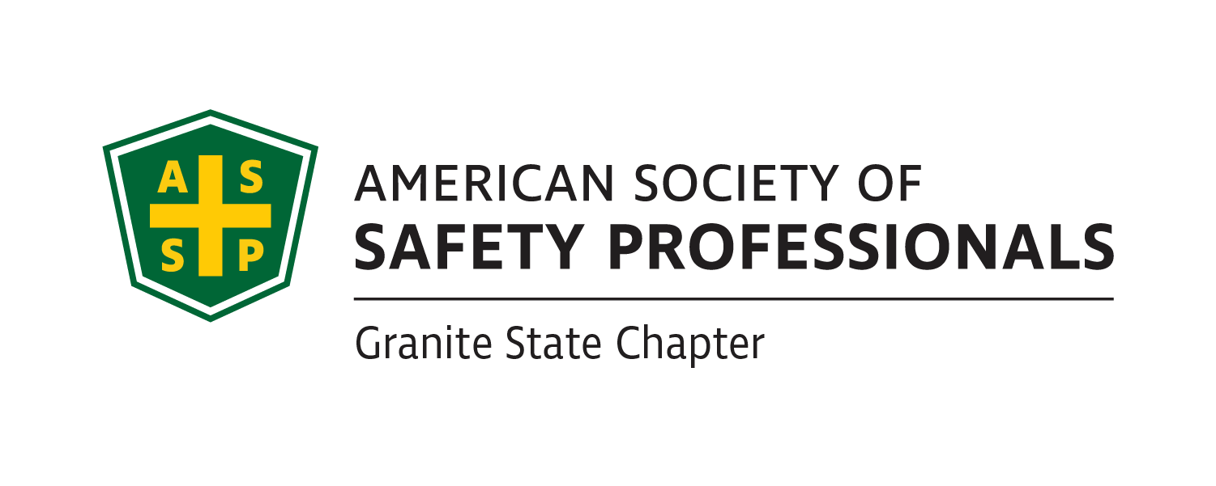
Granite State ASSP Executive Board Meeting 10/7/2022
I. Call to Order- Danielle Cobleigh called the meeting to order at 10:03 am
II. Attendance- Danielle Cobleigh, Joe Orazio, Sam Despins, Jeff Slark, Courtney Simone, Al Parise, Andrew Seller
III. Financial Reports – Danielle
Danielle is working to get Joe Orazio access to the bank account now that Laurie has left. She also discussed that we may go to a different bank due to the problems we have had with TD Bank in the past.
V. New Business
- Bi-Laws Update
  - Make sure to read through the bi-laws and submit any proposed changes to Joe by Nov. 15th
    - Danielle asked that these be done and submitted. There were a lot of grammatical errors noticed so far.
- Training
  - Training was due on Sept. 30th
    - Who has completed it only 2 people reached out to me
    - If you need to still complete it, please work on getting it done
      - Danielle noted that we get a lot of comp points for this.
      - Danielle will send Jeff Slark the links to the trainings.
- Meetings
    - December 1st Meeting- 12pm on Zoom- How to Convince Others Safety is Important
      - Jim Coffman will be presenting.
    - Meeting Ideas
      - First Aid Certificates (Committee Outreach or Keene State)
      - Keene State Meeting (Networking/Mentor Program)
      - Contractor Safety (Collins or Enel)
      - Lab Safety
        - Wanted to do a discussion on why safety is important instead.
      - ASSP Members student panel during class
        - Granite State Chapter had done a panel discussion.
        - Possibly do an in-class meeting in order to try and gain participation. Will need to work with Student Section on this.
      - Jeopardy (Boston, Connecticut student section)
        - Working on logistics of this event.
- New England Area PDC Silent Auction
  - NH Basket
    - Danielle asked if there was anything specific they wanted to see in the basket but nothing was mentioned.
- Deadlines and Assignments
  - Make sure you are using your Binders and the checklists to keep up with their checklist
    - Justin I need an address for you, you binder got returned to me by the post office. But I sent you the stuff you need that was in your binder
      - Justin was absent.
  - Each member of E-board will contribute two articles throughout the year to the newsletter, they can be on the EHS topic of your choosing, please send them to Ashley Arnold by the 5th of the months that you are assigned.
    - November is Ashley and Sam.
      - Danielle reminded Sam that he is responsible for an article this month and to send it to Ashley for the Newsletter.
VIII. Old Business
- Leadership Conference Virtual October 21-22
  - Danielle, Al, and Joe attended
    - Attendees felt the event went well and provided some good information.
IX. Round the Table
Sam Despins- Asked about a deadline for scholarship information. Sam will reach out to Michelle, Courtney and Danielle to set up the meeting. Chapter got the scholarship information out late so the deadline was extended to ensure this allowed for additional time to submit.
Danielle Cobleigh let the board members know that we will be trying to work with OTIEC to offer CEUs for the OSHA Roundtable and develop a partnership.
Sam Despins spoke about the students’ interest in professional credentials (CSP, MBA, etc.) and suggested doing a presentation on how we could leverage this into another session.
- Sam mentioned that we are trying to figure out why we struggle to get younger members to participate and this may be a good avenue for us to engage with them.
Danielle to send Courtney a link for the XXXX
Al Parise- Mentioned sending out invitations to join our chapter has ended up bouncing back.
- Danielle is building a spreadsheet that will have emails removed that bounced back emails from the newsletter and will provide this to Al to potentially reach out via LinkedIn.
Danielle asked the board if there was anyone who wanted to attend the conference but wasn’t able to due to not having a registration.
- No one noted that they were interested or weren’t sure if they would be able to.
- Andrew asked if anything was heard back from the student section regarding their attendees.
  - Joe Orazio let him know that nothing was mentioned after the distribution of the Moderator Opportunities.
X. Adjournment

