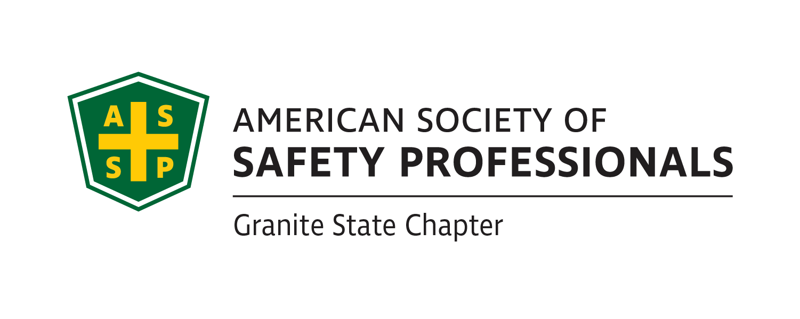

Granite State ASSP Executive Board Agenda 1/20/2023

I. Call to Order 12:05

II. Attendance Joe O, Al P, Ryan E, Danielle C, Michelle W, Ashley A

III. Financial Reports Dec report- last purchase was pizza(4) for meeting with Adam, otherwise steady account

V. New Business

* Webpage & Social Media Updates
  + Newsletter from December- Just sent
* Scholarship Applications Updates- Sam Despins
  + Student Scholarship Leverage Region to match scholarship donation, $1,000 and $500
  + Extend deadline to 1st of April
* Meetings- Joe Orazio
  + Programs Chair Vacancy, potential candidate: Brian Bohan
  + Meetings in the works
    - Adam Henderson with Chemical Safety Board
      * Held meeting on PSM at GZA
      * Presentation went well, reviewed BMPs
    - Jack Padden
      * Agreed to speak on the retractable fall protection ANSI changes taking effected 2/1/22
      * Planning for mid-February
* Deadlines and Assignments
  + Each member of E-board will contribute two articles throughout the year to the newsletter, they can be on the EHS topic of your choosing, please send them to Ashley Arnold by the 5th of the months that you are assigned.
    - February Newsletter- Deadline to 2/5
      * Joe Orazio- President’s Message & Article
      * Michelle Wiltshire- Article
      * Courtney Simone- Article
      * Allow Companies who have hosted ASSP meetings to be able to have advertisement in Newsletter
* Job Board Postings
  + Ryan to provide Ashley and Courtney with listing for incorporation into newsletter and webpage.

VIII. Old Business

IX. Round the Table

X. Adjournment 12:20