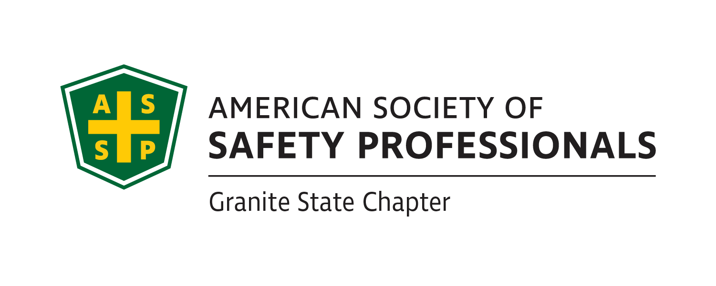

Granite State ASSP Executive Board Minutes 4/21/2023

I. Call to Order

II. Attendance- Joe Orazio, Danielle Cobleigh, Sam Despins, Andrew Sellers, Al Parise, Ryan Emerson

III. Financial Reports- Joe Orazio

V. New Business

* Webpage & Social Media Updates- Joe Orazio let the committee know that the information that was missing from the webpage was provided to the Social Media Chair and will be updated.
  + Meeting Minutes
  + Newsletters
  + Job Postings List for April
  + May Technical Meeting Info
* Scholarship Applications Updates- Joe Orazio
  + Student Scholarship- The Keene State Student Section’s last week of class is this week and the Chapter did not do a scholarship this semester.
* Spy Award- Sam Despins will be getting Joe Orazio the information with the link and QR code and this will go out to membership as soon as it is received.
* Board Slate for Election
  + Going out next week now that the Survey Monkey log in information is available.
  + Still need a President Elect; the slate published will not have a President Elect.
    - Joe Orazio reviewed how the Chapter has a very clean tool to use when establishing the annual plan, roles and responsibilities and allowing for a smooth transition from one year to another.
* Meetings- Joe Orazio
  + Meetings in the works and past meeting
    - Gregory Menafo with KSC Student Section
    - Joint Technical Meeting with Greater Boston Chapter on May 4th
      * Rena Harrington, Jeff Myung, Dave Crowley, Joe Orazio
* Deadlines and Assignments
  + Each member of E-board will contribute two articles throughout the year to the newsletter, they can be on the EHS topic of your choosing, please send them to Ashley Arnold by the 5th of the months that you are assigned.
    - May Newsletter Articles
      * Joe Orazio- President’s Message; supporting organizations; tech meeting invites
      * Michelle Wiltshire- Article- February- please provide for May
      * Courtney Simone- Article- February- please provide for May
      * Andrew Sellers- Article- May
* Job Board Postings
  + Ryan to provide Ashley and Courtney with listing for incorporation into newsletter and webpage.

VIII. Old Business

IX. Round the Table

X. Adjournment